St Francis College For Women
HYDERABAD
Academic year 2024-25
Department of Economics
A meet and greet session was conducted by the fire club on 16th July,2024 from 10:30 to 11:30.It was attended by the first, second and the final year students of economics. The event was held in Gerosa Hall .The core committee of the year 2024-25 were also introduced.
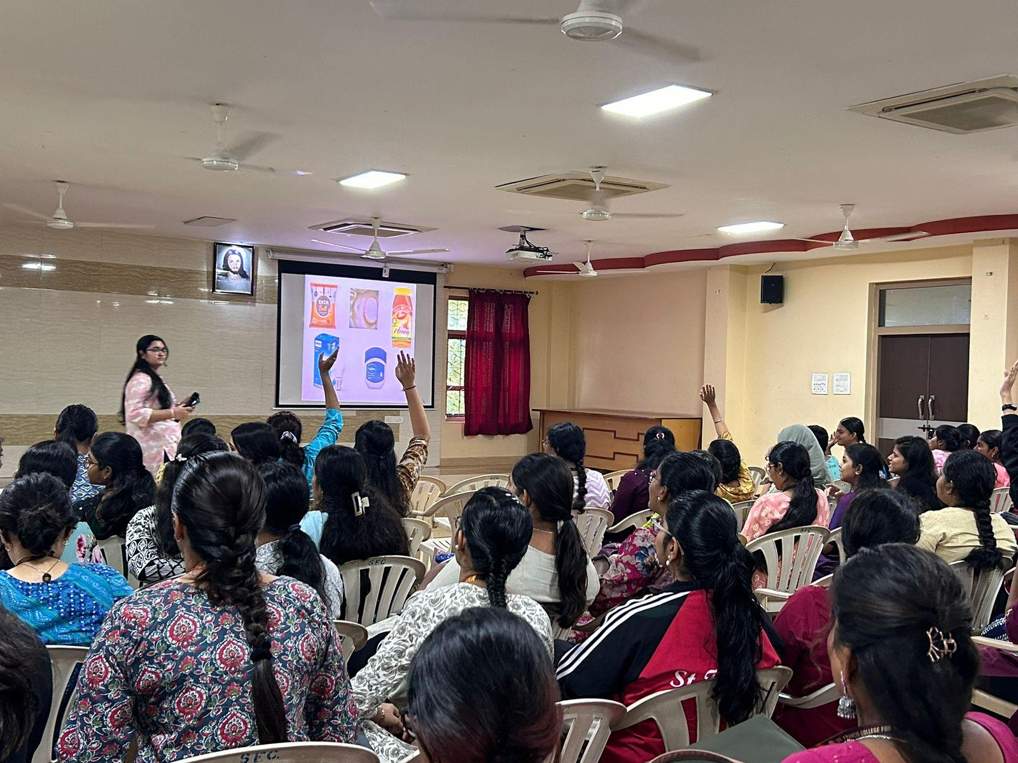
The event commenced with activities the first game was unscrambling the jumbled economic terms which had 2 rounds and the other game being Guess the price where the students were asked to predict the prices of the commodities which also had two rounds. The event concluded with meet and greet of the first ,second and the final year students which proved to be true to it's name.

